DIABETES MELLITUS: ETIOLOGY, PATHOGENESIS AND MODERN LABORATORY DIAGNOSTICS

Diabetes mellitus remains relevant, creating a serious medical and social problem for the health care system around the world. In modern times, there has been a rapid spread of diabetes mellitus and an increase in disability and mortality due to this disease. Diabetes mellitus belongs to the group of hereditary (polygenic) and rarely autosomal dominantly transmitted diseases, is characterized by all types of metabolic disorders and is a disease that requires complex correction.
Etiopathogenesis. Diabetes mellitus is caused by absolute (intrapancreatic) and relative (extrapancreatic) insulin deficiency according to the mechanism of formation and belongs to the group of chronic metabolic diseases accompanied by hyperglycemia. Absolute insulin deficiency develops as a result of destructive changes in the islets of Langerhans of the pancreas. Relative deficiency of insulin occurs against the background of other diseases that do not depend on the pancreas. In diabetes mellitus, the function of cells to synthesize insulin, the excretion of synthesized insulin, or the use of insulin by tissues is impaired. Insulin is an essential hormone that has hypoglycemic, anabolic and mitogenic effects (Fig. 1).

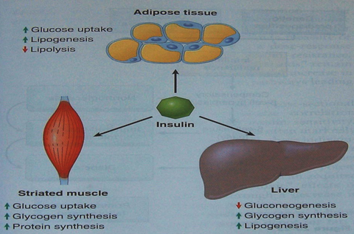

The hypoglycemic effect of insulin is explained by the weakening of gluconeogenesis and glycogenolysis in the liver, the anabolic effect of lipogenesis, glycogenesis, proteinogenesis and the mitogenic effect of stimulating cell proliferation. According to etiopathogenesis, primary (spontaneous) and secondary diabetes mellitus are distinguished. There are 2 types of primary diabetes: type I and type II. Secondary diabetes occurs against the background of other diseases. This disease develops during pancreatic damage, endocrine diseases accompanied by hypersecretion of counterinsular hormones (Cushing's syndrome, acromegaly, pheochromocytoma, thyrotoxicosis, glucagonoma, etc.), a number of chromosomal diseases (Down, Klinefelter) and etc.
Type I diabetes occurs mainly in people under the age of 30 and accounts for 10% of all cases of diabetes. At this time, as β-cells are damaged, insulin secretion decreases and absolute insulin deficiency develops. This type of diabetes is accompanied by hypoinsulinemia and hyperglycemia. In the formation of type I diabetes, a hereditary predisposition associated with the MHC gene, autoimmune aggression against β-cells, and the influence of β-cytotropic viruses and β-cytotropic chemical factors play an important role (Fig. 2).

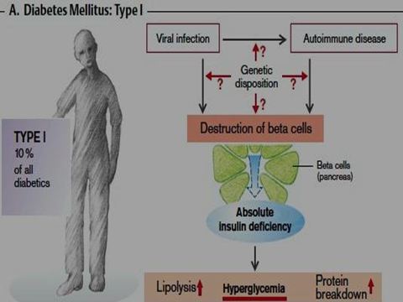

Type II diabetes occurs mainly after 30 years of age and accounts for 80-90% of all cases of diabetes. At this time, hyperglycemia and hyperinsulinemia occur. Hyperinsulinemia is accompanied by insulin resistance. Genetic predisposition and obesity play a role in the etiology of type II diabetes. Genetic predisposition mainly refers to a defect in the factors involved in the regulation of carbohydrate metabolism (Fig. 3).
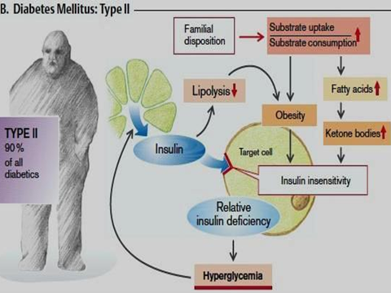

As a result of a violation of the ratio between the production of insulin and its utilization in diabetes mellitus, carbohydrates, proteins, fats, water-salt, etc., metabolism is disturbed. As a result of carbohydrate metabolism disorders, symptoms of hyperglycemia, glucosuria, polyuria and polydipsia develop. Symptoms such as hyperlipidemia, ketonemia and ketonuria are observed in violation of lipid metabolism in diabetes. Protein metabolism in this disease
disturbed, hyperazotemia and azoturia occur. The occurrence of symptoms such as polyuria, hyperkalemia, hyponatremia in diabetes mellitus indicates a violation of water and electrolyte metabolism. Diabetes mellitus is characterized by acute and delayed complications. Acute complications include hyperglycemic (ketoacidotic, hyperosmolar and lactatesidemic) and hypoglycemic coma, delayed complications include macro- (coronary, cerebrovascular and peripheral vessels) and microangiopathies (blood vessels of the retina, kidneys and peripheral nerves) and neuropathies.
The diabetic foot is usually the result of a combined development of both microvascular and macrovascular dysfunctions. Hyperglycemic ketoacidotic coma is observed in patients with type 1 diabetes mellitus, and acute hyperglycemia, hyperketonemia, and metabolic acidosis play an important role in the pathogenesis of this coma. With a lack of insulin, the process of lipolysis is accelerated, the amount of free fatty acids in the blood increases. Free fatty acids are transported to the liver and accelerate ketogenesis. An excess of ketone bodies affects the central nervous system and causes coma (Fig. 4).
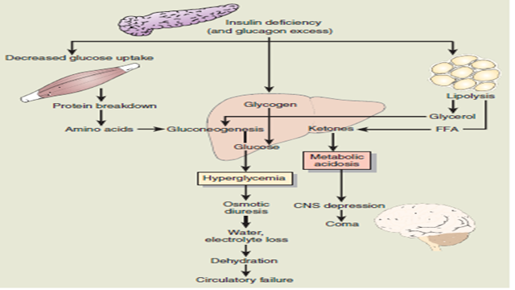

Hyperglycemic hyperosmolar coma is typical mainly for patients with type II diabetes mellitus. The pathogenesis of hyperosmolar coma is based on hyperosmolality of the blood and dehydration of the body. At this time, cells, especially brain cells, become dehydrated, hypoxia and fainting in the central nervous system occurs. Ketoacidosis does not occur in this type of diabetes. Hyperglycemic lactatasidemic coma develops in patients with internal organ failure on the background of diabetes. At this time, the amount of lactic acid in the blood increases, resulting in a lactic-acidemic coma. With hypoglycemia, the concentration of glucose in the blood is below 3.9 mmol / l. With a relatively mild form, the patient can restore the sugar level on their own. Severe forms of hypoglycemia adversely affect brain cells and pose a threat to life.

The pathogenesis of angiopathies, which are delayed complications of diabetes mellitus, is based on the non-enzymatic connection of glucose with proteins without the participation of enzymes. In the process of glycosylation, glycoproteins with stable compounds are formed and deposited on the vessel wall. As a result, the development of sclerotic changes in the vessel wall is observed. Corresponding pathologies develop in tissues fed by vessels that have undergone sclerotic changes. Another mechanism for the development of delayed complications of diabetes mellitus is the acceleration of the conversion of intracellular glucose into sorbitol. Normally, 1-2% of intracellular glucose is converted into sorbitol, and in diabetes, the formation of sorbitol increases by 8-10 times. As a result, intracellular osmolality increases, water moves into the cell, and osmotic damage occurs (Fig. 5).
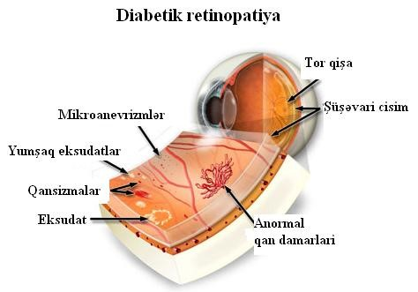
. 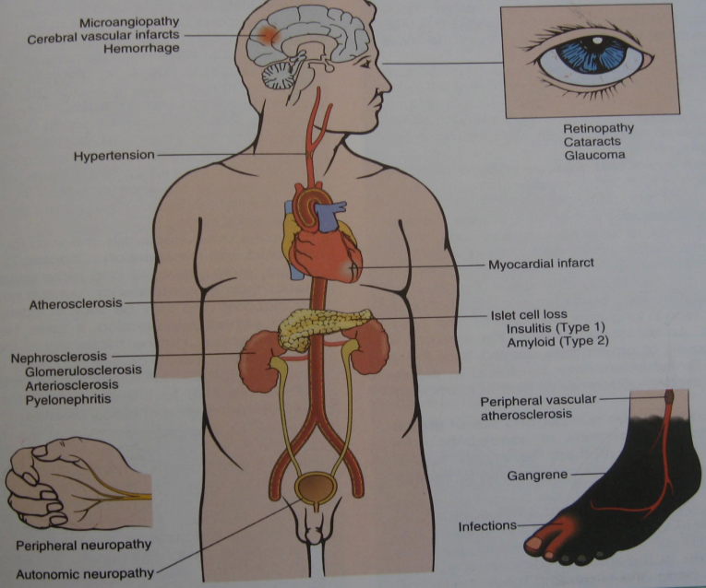

When examining a patient with diabetes mellitus, the doctor should first of all take into account risk factors.
Risk factors include:
Age ≥ 45 years
Overweight or obesity
Passive lifestyle
Family history of diabetes
History of carbohydrate metabolism disorders
Gestational diabetes or birth weight > 4.1 kg
Arterial hypertension
Dyslipidemia (high-density lipoprotein [HDL] < 35 mg/day [0.9
mmol/L] or triglycerides > 250 mg/dL [2.8 mmol/L])
Having a history of cardiovascular disease
Polycystic ovaries and etc.
The symptoms that lead to the determination of the concentration of sugar in the blood are as follows:
Constant feeling of thirst (polydipsia),
Frequent urination (polyuria),
Increased appetite (polyphagia),
Weight loss against the background of polyphagy,
Overweight (obesity),
Dry skin and mucous membranes;
Sleep disorder,
Muscle weakness,
Spasms of surrounding muscles and etc.
Laboratory tests for diagnosing diabetes mellitus:
* Determination of sugar in the blood should be carried out on an empty stomach.
Based on the result obtained, if the concentration of glucose in the blood is higher than normal, we cannot diagnose diabetes mellitus without conducting other examination methods in such a patient. Because such hyperglycemia cannot be considered diabetes without clinical manifestations or diabetic complications. Established hyperglycemia can be observed in various pathologies of the pancreas and with an increase in the level of contra-insular hormones.
* A glucose tolerance test is performed.
If the concentration of glucose in the blood exceeds the critical limits, the examination is not carried out. If the determined concentration of glucose in the blood is in the range from 3.88 to 7 mmol / l, it is too early to talk about hyper- or hypoglycemia and the patient's condition should be clarified. The study is also prescribed for people with risk factors for developing diabetes.The examination is carried out in the morning, before meals and no later than 8 hours after the last meal. The patient should be in a calm state, not subjected to physical strength and stress. If the blood glucose level is more than 7 mmol / l, the test is not performed. First of all, blood is taken from the patient and glycemia level is measured with a glucometer. Then the patient is given orally 300 ml of water dissolved in 75 g of glucose. Blood is taken again after 2 hours. According to the test result, if the concentration of glucose in the blood is less than 7.8 mmol / l, this positive result is considered as a violation of tolerance from 7.8 to 11.0, if the glycemia is more than 11.0 - diabetes mellitus is diagnosed. Note that this test is a very sensitive test and is rarely used in the clinic. It can be said that the glucose tolerance test is more used in gestational diabetes and in scientific work.
* Determination of the level of glycosylated hemoglobin (HbA1C). The purpose of the prescription is to distinguish short-term hyperglycemia from long-term hyperglycemia. The study is based on the determination of glycated hemoglobin (an irreversible substance formed as a result of the non-enzymatic combination of glucose and hemoglobin) in the blood. The determination reflects the level of HbA1C in the blood during the 3 months preceding the examination (this is the time during which erythrocyte with modified hemoglobin can remain in the blood). This is an important research method for predicting and diagnosing complications of diabetes mellitus. The result obtained indicates the effectiveness of the treatment of the disease and the need for correction. If the HbA1C level exceeds 8%, a correction of treatment tactics is urgently required. Special preparation before analysis is not required. Results are independent of food intake, exercise and time of day. The study is used to diagnose diabetes and monitor the dynamics of the disease.
HbA1C ≥ 6.5% diabetes mellitus
HbA1 C=5.7-6.4% is considered as an increased risk of developing diabetes.
* Determination of acetone, glucose and protein in the urine.
Normally, neither glucose nor acetone is detected in the urine.
* Determination of insulin in the blood.
With prolonged hyperglycemia, it is necessary to determine the level of insulin. Insulin concentration rises in response to a high concentration of glucose - this is natural and physiological. Venous blood is used for analysis. It is recommended to conduct this test together with the glucose tolerance test. It is recommended to be taken together with. During the study, the stomach should be empty and it should be carried out after an 8-hour break in eating. During the examination, physical activity, eating, smoking, etc. should be avoided.
* Determination of fructosamine in the blood.
Fructosamine is a glycosylation product of plasma proteins. The level of fructosamine in the blood is a positive indicator in patients with diabetes mellitus. If the glucose level remains high for a certain period of time, the glucose molecules non-enzymatically combine with the protein to form a glycosylated protein. This protein is a persistent compound that is deposited on the vessel wall and causes sclerotic changes.
* Determination of C-peptide in the blood (this is a polypeptide, consists of 31 amino acids, and proinsulin is cleaved into insulin and C-peptide by the action of peptidases). Normally, the level of this substance corresponds to the concentration of insulin in the blood and equals 0.9-4 ng/ml. In diabetes mellitus, the concentration of C-peptide decreases. Blood for analysis is taken on an empty stomach.
* Determination of leptin in the blood.
Leptin is a hormone that regulates appetite and body weight. İt is synthesized by adipocytes. The normal range is 1.1 - 27.6 ng/mL for men and 0.5 - 13.5 ng/mL for women. Leptin levels decrease in obesity. Blood for analysis is taken on an empty stomach.
* Determination of antibodies in the blood.
Anti-β-cell or glutamate decarboxylase antibodies may be detected in individuals at high risk of developing type 1 diabetes before clinical onset of the disease. The detection of antibodies in the blood is an indicator of autoimmune destruction of β-cells.
* Conducting a biochemical blood test.
* Study of the electrolyte composition of the blood.
Individuals diagnosed with diabetes should be screened annually to detect late complications of the disease. Surveys carried out include the following:
* Examination of the lower limbs.
This examination should be carried out at least once a year, pulsation in the veins of the foot, pain, temperature sensitivity, nerve sensitivity, etc. should be checked. These symptoms are characteristic of peripheral neuropathy.
Sensation in the lower limbs is checked with an instrument called a monofilament esthesometer (Figure 6).

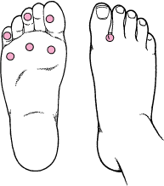
Figure 6. Examining the foot with a device called a monofilament esthesometer.
The principle of operation of a device called a monofilament esthesiometer: an esthesiometer with 10 g of monofilament is pressed on certain areas of each leg and squeezed to a bend. This test determines the sensitivity of the nerves of the extremities. The test is carried out on both legs and note the presence (+) or absence (-) of sensitivity in each place. In addition, skin cracks on the limbs, wounds, condition of the nails, etc. are checked.
* Determination of the activity of protein kinase C.
The decrease in the activity of protein kinase C is more pronounced in diabetes mellitus and especially in angiopathy.
* Measurement of blood pressure, detection of dyslipidemia (hypertension is usually determined in diabetes mellitus).
Atherosclerosis of large vessels occurs with macroangiopathy, which causes angina pectoris, myocardial infarction, transient ischemic pain.
One of the clinical manifestations of microangiopathies is diabetic retinopathy. Retinopathy is the most common cause of blindness.
* The patient's retina should be examined regularly (usually once a year). To prevent blindness, it is necessary to carry out early diagnosis and timely treatment.
Diabetic nephropathy is another complication of diabetes. Diabetic nephropathy leads to thickening of the basement membrane of the glomeruli and the formation of glomerulosclerosis. These changes are accompanied by an increase in glomerular pressure and a gradual decrease in glomerular filtration rate.
*Diabetic nephropathy is based on urinary albumin levels.
Monitoring the level of albumin in the urine can detect nephropathy in the early stages of diabetes mellitus. Diabetic nephropathy is confirmed by testing the albumin/creatinine ratio or urinary total albumin using dipstick reagents. Albumin/creatinine ratio > 30 mg/g (> 3.4 mg/mmol) or urinary albumin excretion 30-300 mg/day – it is an early diabetic nephropathy, if albumin concentration > 300 mg/day, it is a progressive diabetic nephropathy.
Urinary excretion
If the albumin concentration exceeds 300-500 mg / day, the test with an indicator strip is considered positive.
The next complication is diabetic neuropathy.
Most often, symptoms such as paresthesias, loss of proprioceptive and temperature sensation, formation of late-healing wounds limbs (in the form of "socks" and "gloves") and etc. occur in the distal part of the.
All diabetics should consult the following specialists:
Endocrinologist
Cardiologist
Neurologist
Ophthalmologist
Surgeon (vascular surgeon or special orthopedic doctor who examines the foots of diabetic patients)
Features of surgical intervention in diabetes mellitus.
As you know, diabetes is a disease characterized by metabolic disorders caused by a sedentary lifestyle, unbalanced diet or genetic causes. In type I diabetes, the body does not produce insulin, and insulin injections injected into the body are used to treat this type of diabetes. In type II diabetes, the body produces insulin, but the patient cannot use it. Therefore, blood sugar levels are always high. As a result, hyperglycemia causes organ damage. The classic treatment for diabetes is to lower blood sugar levels. Recently, surgery for diabetes mellitus is considered as a method of treating the disease. This operation, called metabolic surgery, is performed on patients with type II diabetes.
Indications for surgery: type II diabetes mellitus, high hyperglycemia, overweight despite taking drugs and insulin (in the form of injections). Surgery is performed as a closed operation through small incisions. 50% of the stomach is removed, changes are made in the small intestine. Within two years after the operation, a person loses up to 80% of his weight. Thus, type II diabetes mellitus completely disappears. Also, after this operation, people get rid of obesity too (photo 7).

Figure 7. Surgery for type II diabetes

Thus, the secreted insulin is used by the body. As a result, the high concentration of sugar in the blood decreases and insulin resistance disappears.

